1. Created 3 server as per need
1. JenKins Tomcat | 2. SonarQube | 3. Nexus
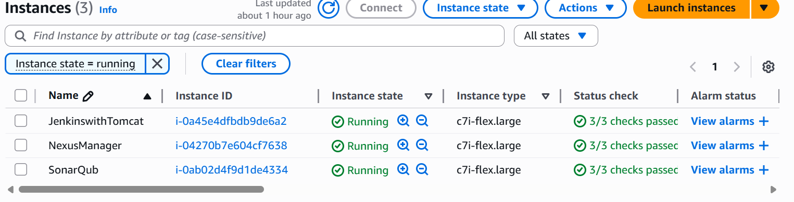
2. Enable the Server-1 with Jenkins and Tomcat with a shell script.
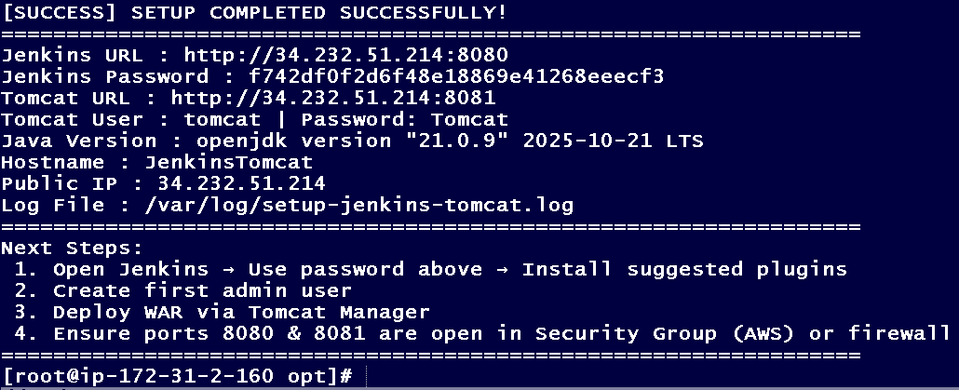
3. Validate the Jenkins access with ip given.
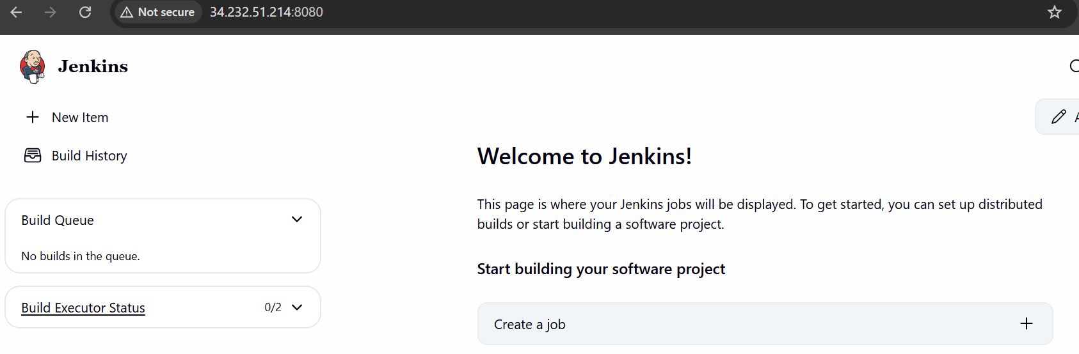

4. Validate the Tomcat access with ip given
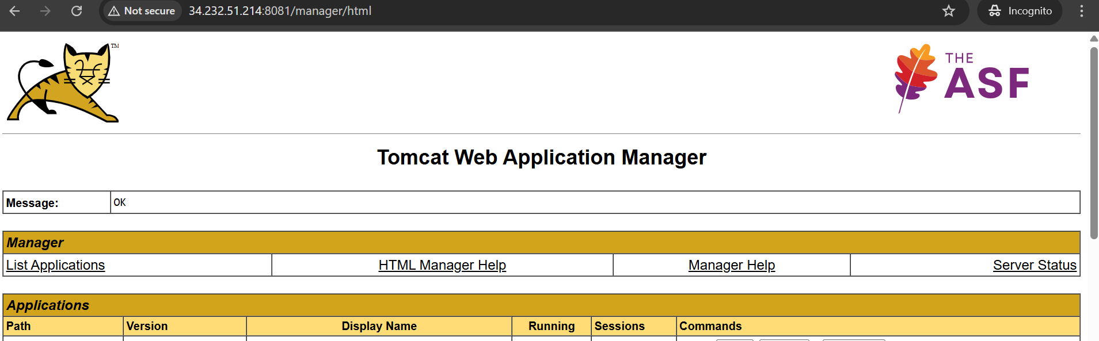

5. Create pipe line for the GIT – clone.
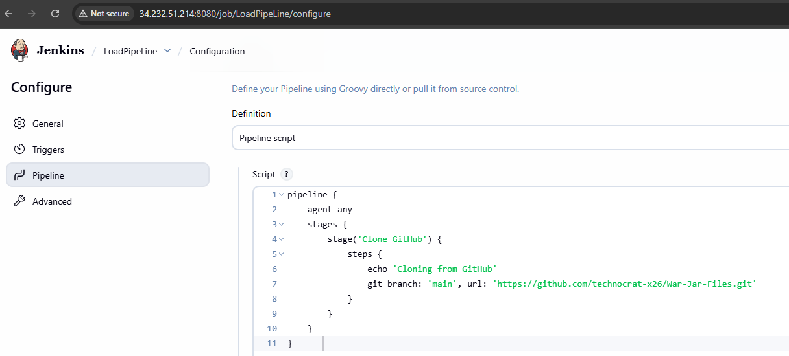
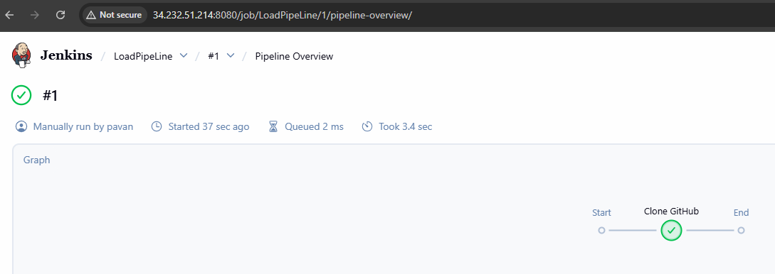

6. Modify pipe line for the GIT + Maven build.
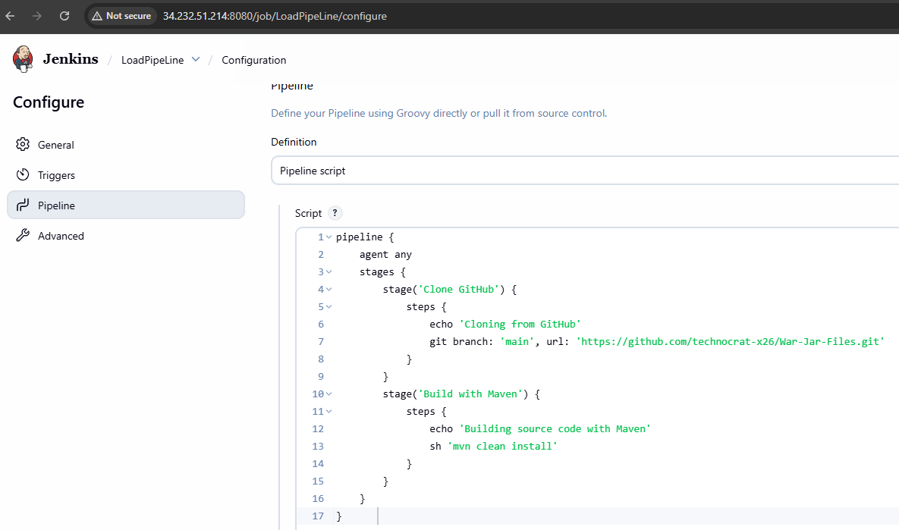
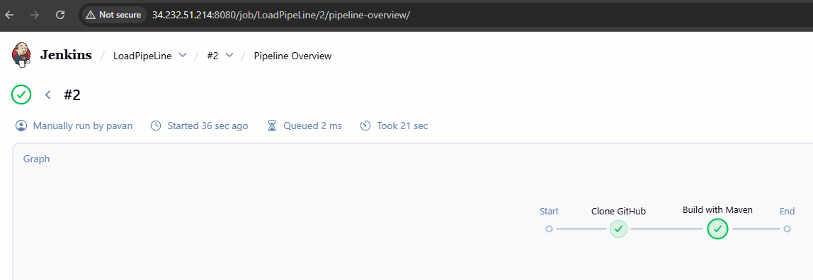

7. create pipe line for the GIT + Maven build + Tomcat Deploy.
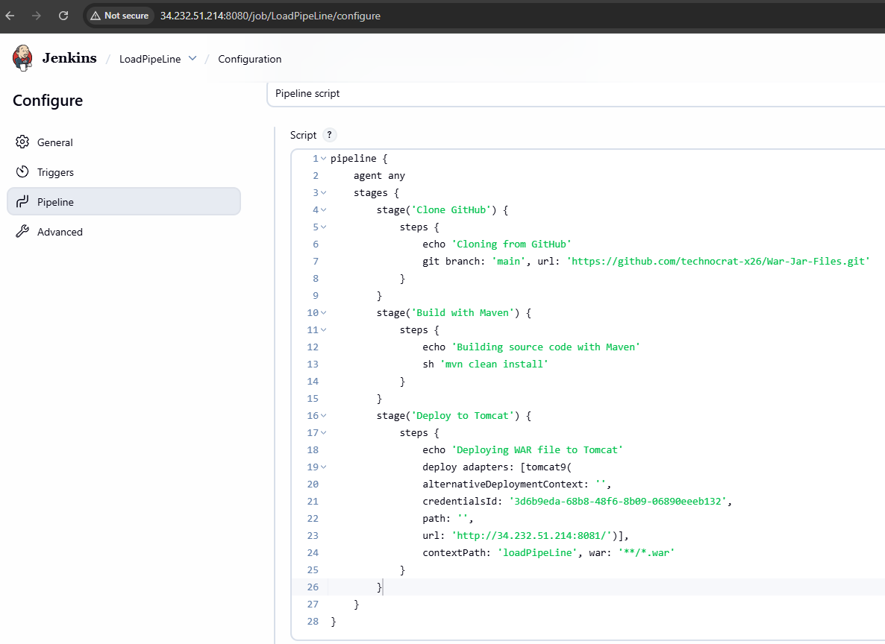

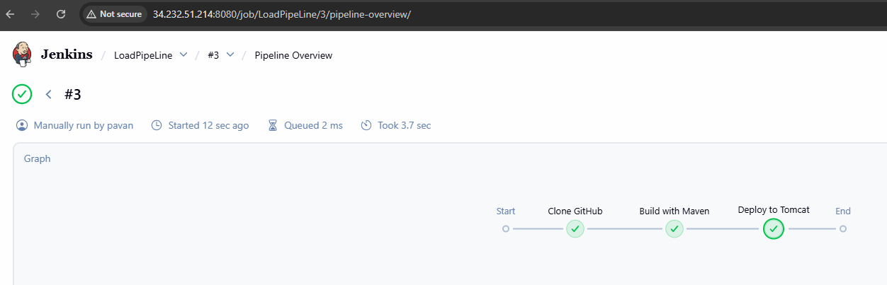

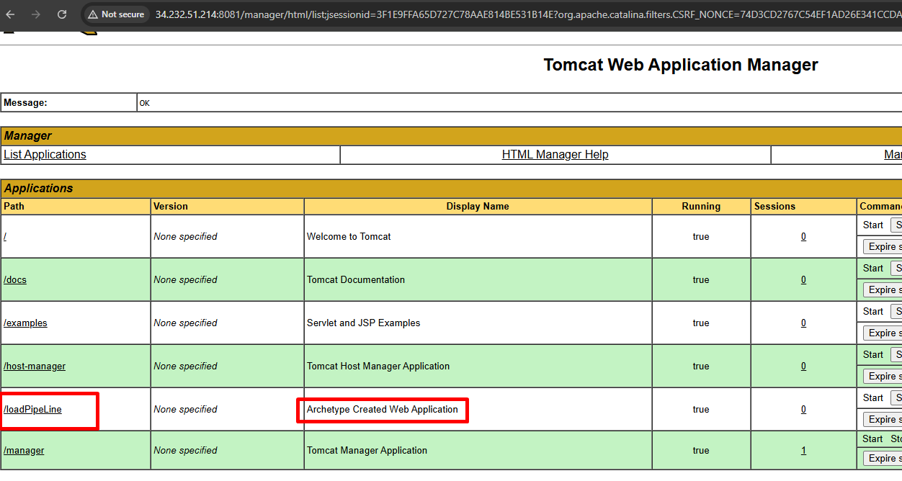

Server 2 – SonarQube
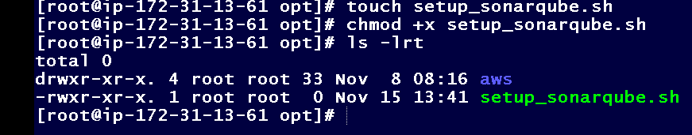
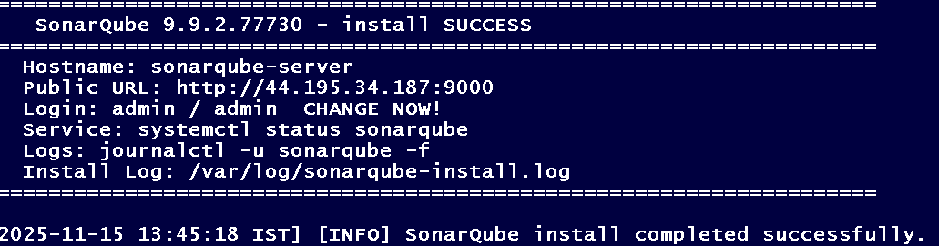
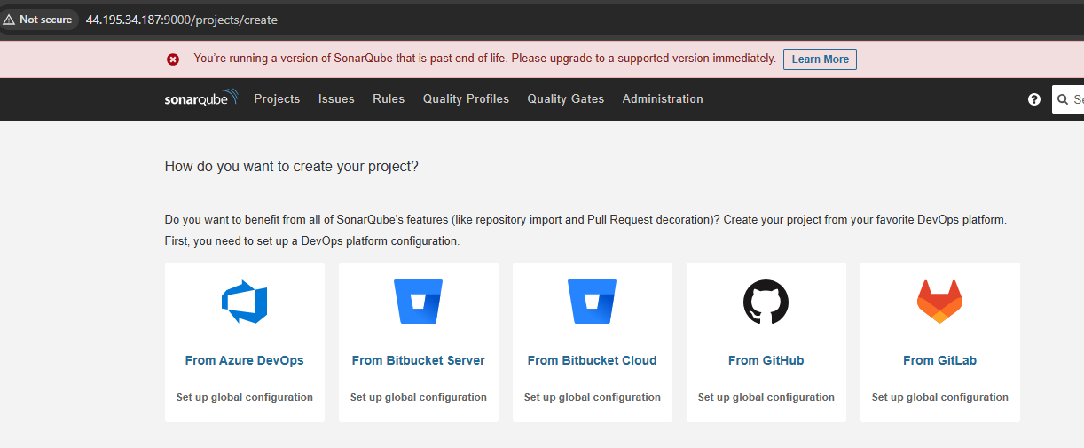
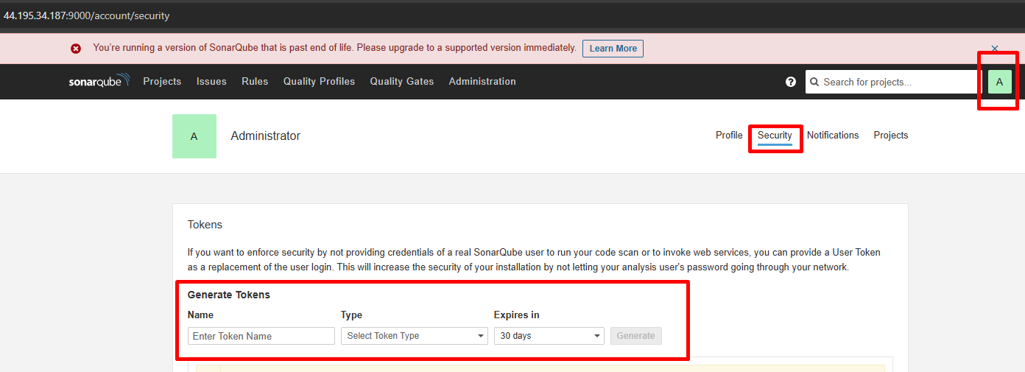
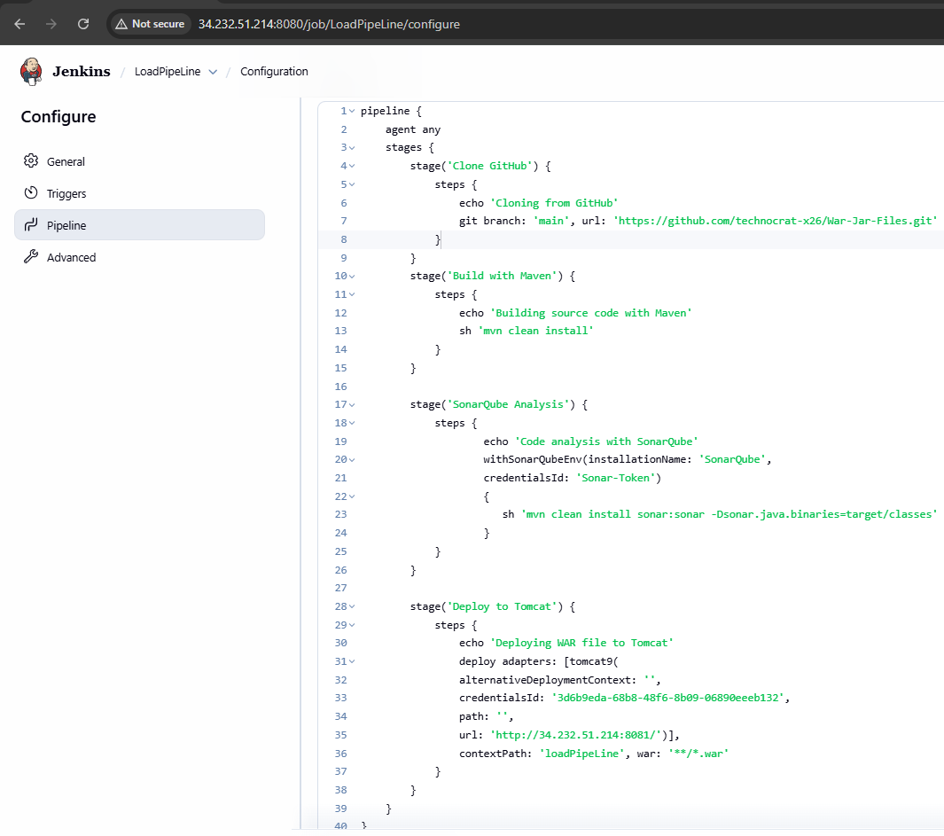
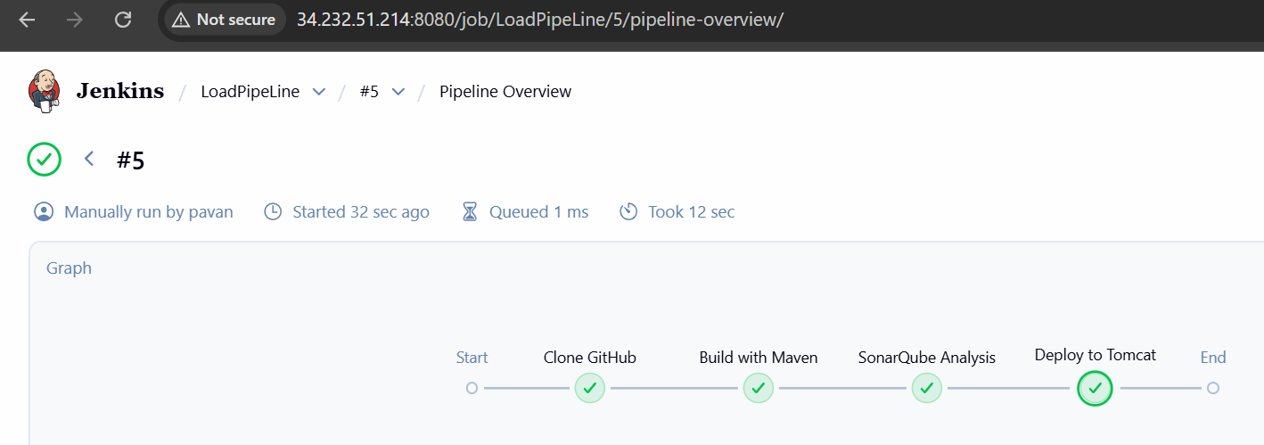

- Server3 - Nexus
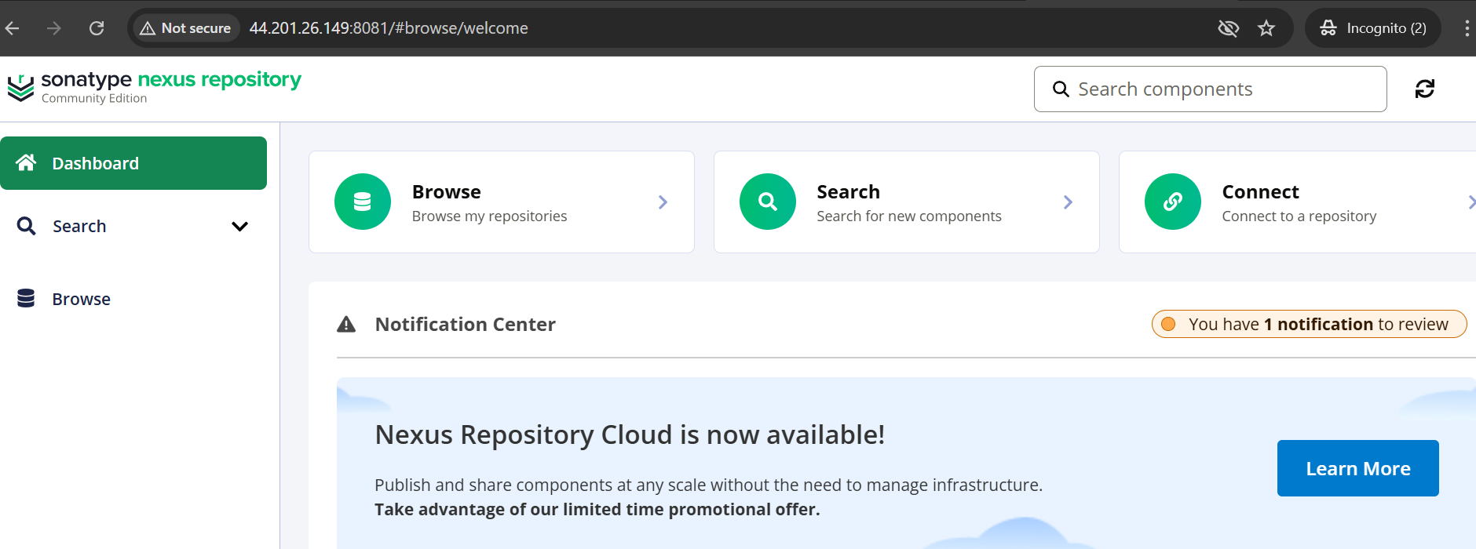

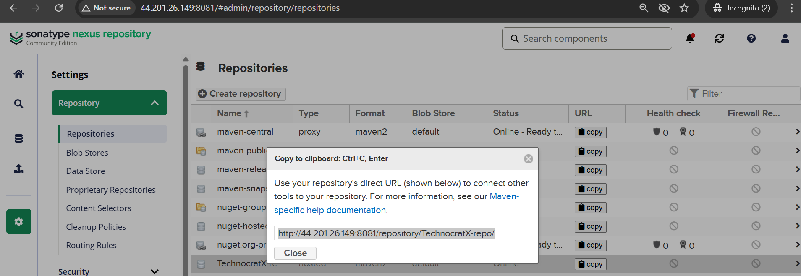
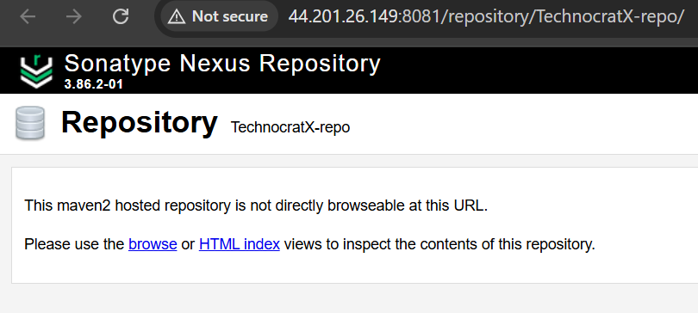
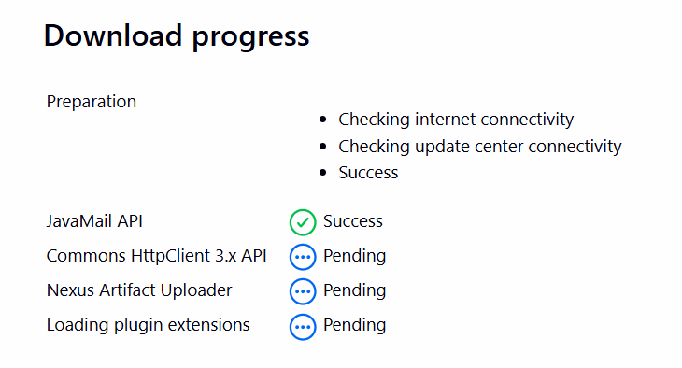

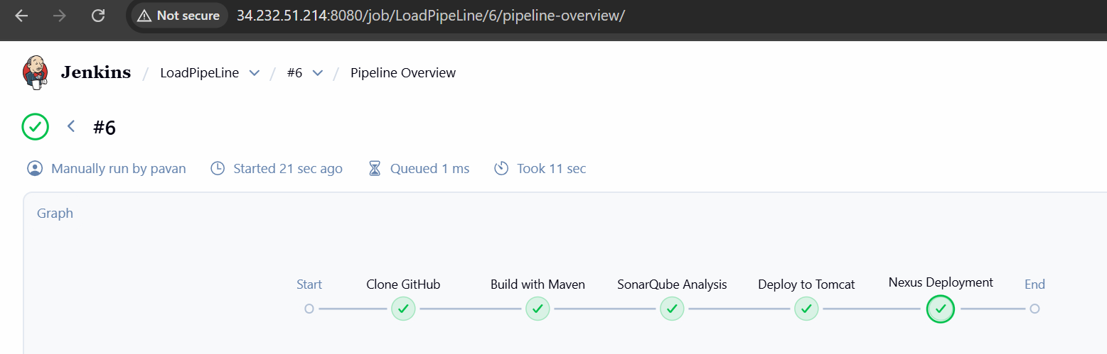
pipeline {
agent any

stages {
stage('Clone GitHub') {
steps {
echo 'Cloning from GitHub'
git branch: 'main', url: 'https://github.com/technocrat-x26/War-Jar-Files.git'
}
}

stage('Build with Maven') {
steps {
echo 'Building source code with Maven'
sh 'mvn clean install'
}
}

stage('SonarQube Analysis') {
steps {
echo 'Code analysis with SonarQube'
withSonarQubeEnv(installationName: 'SonarQube', credentialsId: 'Sonar-Token') {
sh 'mvn clean install sonar:sonar -Dsonar.java.binaries=target/classes'
}
}
}

stage('Deploy to Tomcat') {
steps {
echo 'Deploying WAR file to Tomcat'
deploy adapters: [tomcat9(
alternativeDeploymentContext: '',
credentialsId: '3d6b9eda-68b8-48f6-8b09-06890eeeb132',
path: '',
url: 'http://34.232.51.214:8081/'
)],
contextPath: 'loadPipeLine',
war: '**/*.war'
}
}

stage('Nexus Deployment') {
steps {
echo 'Nexus deployment step'
nexusArtifactUploader artifacts: [[
artifactId: 'helloworld',
classifier: '',
file: 'target/helloworld.war',
type: 'war'
]],
credentialsId: 'Nexus',
groupId: 'example.demo',
nexusUrl: '44.201.26.149:8081',
nexusVersion: 'nexus3',
protocol: 'http',
repository: 'TechnocratX-repo',
version: '1.0-SNAPSHOT'
}
}
}
}

